Objectives:
Introduction to Math CCRS
KSS 2019 with Kyle Markwalter
markwaltermath.weebly.com
kyle.markwalter@kippsanjose.org

Teachers Wil Be Able to:
- Describe what a CCRS strand story is and how it helps them plan material.
- Calendar College and Career Readiness Standards into their long term plans using the CCRS tools available on KIPP Share
- Design a lesson that integrates a single College and Career Readiness Standard into the day's work.

What Are the CCRS Standards?
Notes:
This Session: we are going to use the materials available on KIPP Share to help us get ready to monitor and assess students with the CCRS in mind.
CCRS Resources
KIPP Share: Resources by Topic>Assessment>ACT Standards and Assessment System
- College & Career Readiness Standards Charts
- Pacing Plans (and changes)
- Interim Assessments for your course

Practice: Identifying Strand Stories & Power Standards
Emphasized Strand Stories | Standards | Student Skills and Knowledge Needed

Planning CCRS into Your Course
Your job now: Adjust your long term plan and unit plans to address the identified standards!
Notes:

Practice: Calendaring CCRS
Use your course’s long term plan (available on KIPP Share or you might have yours).
Your unit and lessons plans might also prove useful.
Identify specific dates when the standards you recorded in the first practice will be addressed between the beginning of the year and the first IA.
Label those dates and lessons in the long term plan so that you have a record of which CCRS are being covered when.

Final Thoughts:

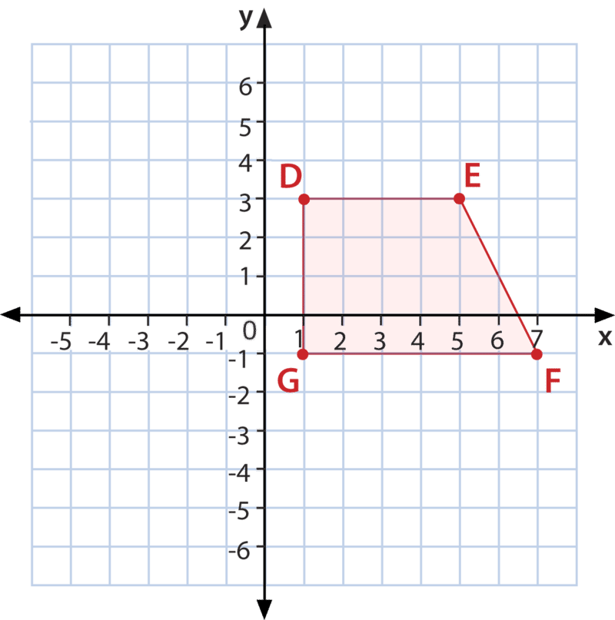
Planning CCRS into Your Lessons
Option 2: “Standard Needs to Be Strengthened in the Lesson” Example
Add problems in a Do Now or in the practice that have students work with the standard.
Standard: G 704 Determine slopes of a line from points or a graph (Algebra IA 1 #9).
Do Now Work in an Algebra Class:
Use the graph of trapezoid DEFG to determine
the slope of $\overline{EF}$. Show all your work.
Option 1: “Standard is Already Addressed” Example
Practice with HOW students will see the standard.
Standard: N 704 Apply properties of complex numbers and the complex number system)
In class work:
Patterns in complex numbers:
Remember, $i=\sqrt{-1}$ So… $i^{0}=_______________$
$i^{2}=_______________$ $i^{3}=_______________$ $i^{4}=_______________$ $i^{5}=_______________$
What is $i^{18}?$ What is $i^{23}?$ What is $i^{17}?$ What is $i^{41}?$

CCRS Practice Question Later in Class:
Which of the following is equivalent to $i^{16}?$
a. $1$ b. $–i$ c. $-1$ b. $i$

Option 3: “Students are Forgetting Things!” Example
Spiral review content for weakening skills.
Solving Linear Equations Strand Story: A 302, A 403, A 502
Review Do Now Before Solving Quadratic Equations Lesson:
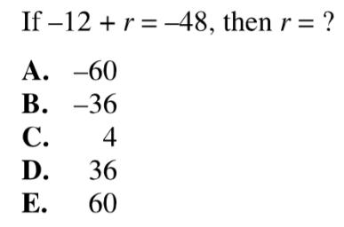
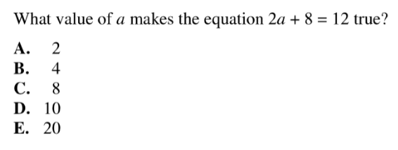
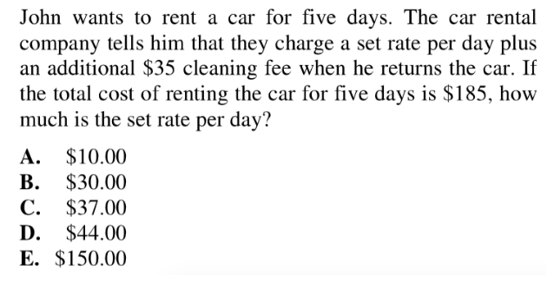

Practice: Outlining a Lesson Plan for CCRS Inclusion
Lesson Title and #
Objective(s)
Standard(s)
CCRS
Possible Agenda
When and How Will CCRS be Addressed in the Lesson?
Possible Problems or Materials to Address CCRS During the Lesson

